AstroAccess – Module 1

Classifying Stars Using Data and Python

Who is this for?
This module is for high school students who are curious about astronomy and want to learn how astronomers actually study stars using data.
You do not need advanced math.
You only need curiosity and a willingness to try.

What is this module about?
In textbooks, we usually memorize star types like:
- Main sequence
- Giants
- Supergiants
- White dwarfs
But real astronomers do not memorize star types.
They:
- Collect data
- Plot graphs
- Look for patterns
- Draw conclusions
In this module, you will do the same thing using Python.

What you will learn in this module
By the end of this module, you will be able to:
- Understand what an Hertzsprung–Russell (HR) Diagram represents
- Use real numerical data of stars
- Plot an HR Diagram using Python
- Identify the likely type of a star from its position on the diagram
- Think like an astronomer, not just a student

What is an HR Diagram? (Simple explanation)
An HR Diagram is a graph that shows:
- Brightness of stars (vertical axis)
- Color or temperature of stars (horizontal axis)
Astronomers noticed that stars do not appear randomly on this graph.
They form clear regions.
Each region tells us something about:
- The star’s size
- The star’s temperature
- The star’s stage of life
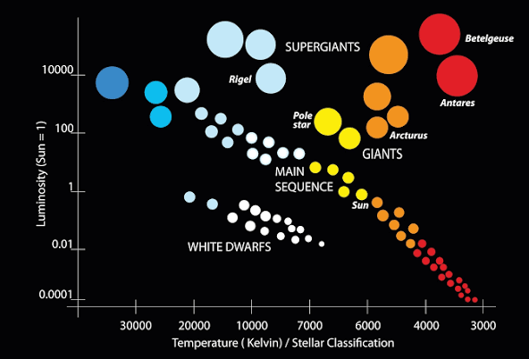

Why do astronomers use data instead of memorizing?
Because:
- New stars are discovered all the time
- Memorization does not work for real research
- Data helps us classify unknown stars
This module focuses on how classification emerges from data.

Your role in this module
You are not just watching or reading.
You will:
- Enter star data yourself
- Run the code
- See the HR Diagram appear
- Interpret what the result means
This is mini research, not a tutorial.

What data will you use?
You will work with simple values such as:
- Color index (for example: BP–RP)
- Absolute magnitude (brightness)
These are the same types of data astronomers use, just simplified.

What tools will we use?
- Python
- Google Colab (runs in your browser, no installation needed)
- Matplotlib for plotting graphs
All tools used here are free and open-source.

How this module is structured
This module has two main parts:

Part 1 — Understanding the idea
- What the HR Diagram shows
- Why stars form patterns
- What different regions mean

Part 2 — Doing the science
- Enter star data
- Plot the HR Diagram using Python
- Interpret the result like an astronomer

Important note (read this carefully)
The classification in this module is simplified.
Real astronomy:
- Uses larger datasets
- Includes uncertainties
- Requires more advanced analysis
This module is a starting point, not the final answer.
That is exactly how real science works.

What you should try after this module
If you want to go deeper:
- Plot many stars instead of one
- Compare different star populations
- Explore how errors affect classification
- Learn basic spectroscopy
Astronomy rewards curiosity.

Why this project exists
This module was created to:
- Make astronomy accessible
- Teach thinking through data
- Help students experience real scientific reasoning
You are not too young to do science.
IN THE NEXT MODULE, BEFORE YOU PLOT THE HRD YOURSELF, YOU WILL LEARN SOME THEORY ABOUT THEM.

End of Module 1

